Lab 7

Bushra dajam

2110054

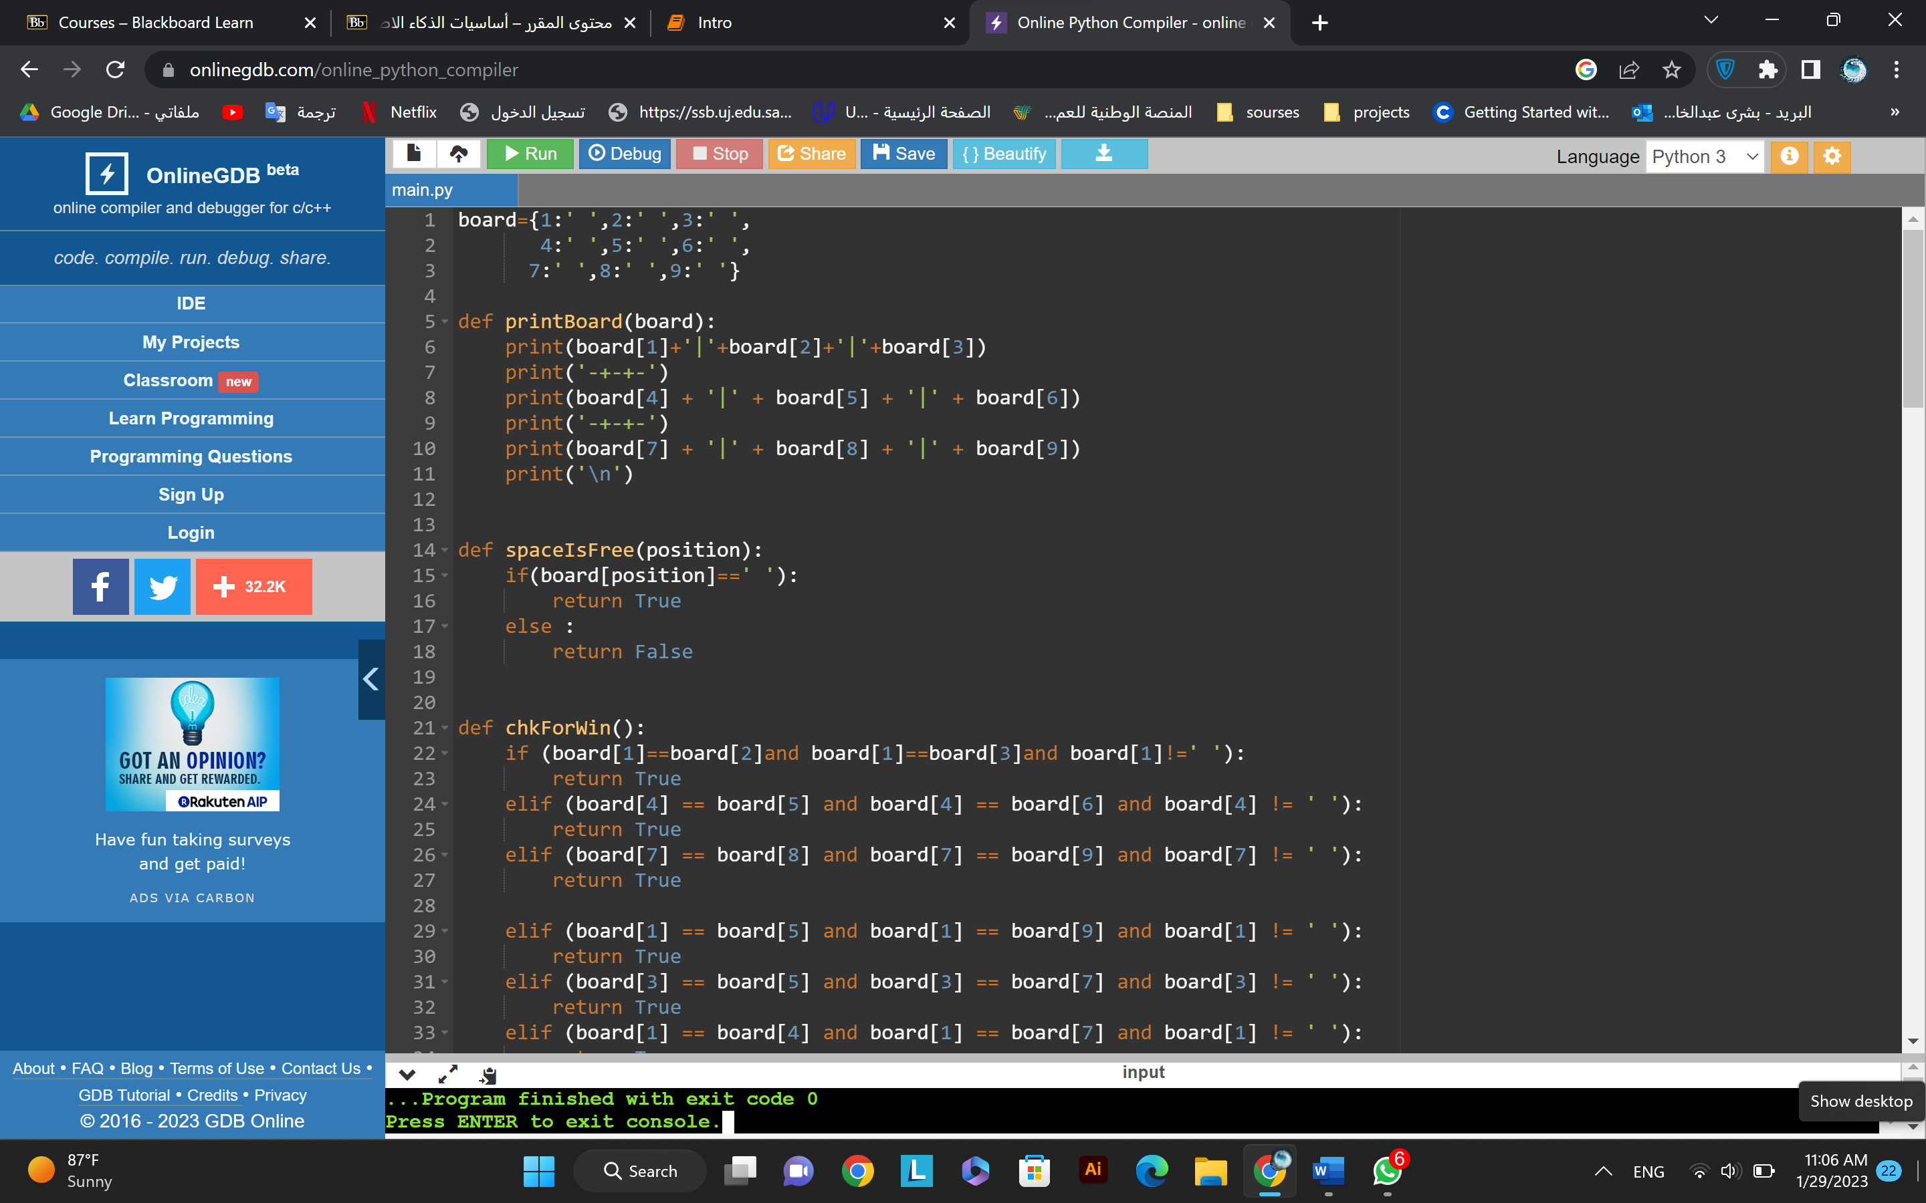

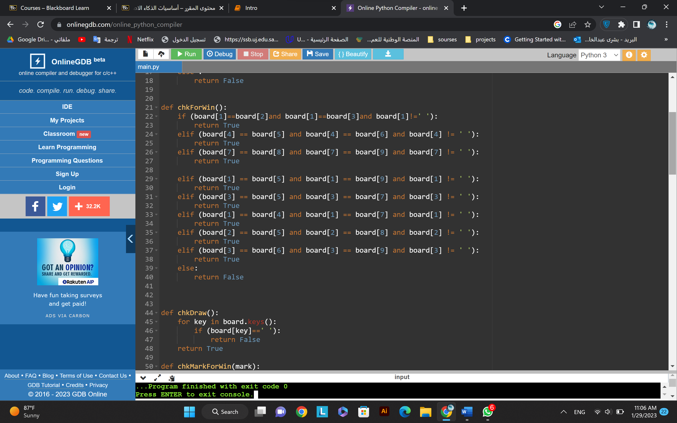

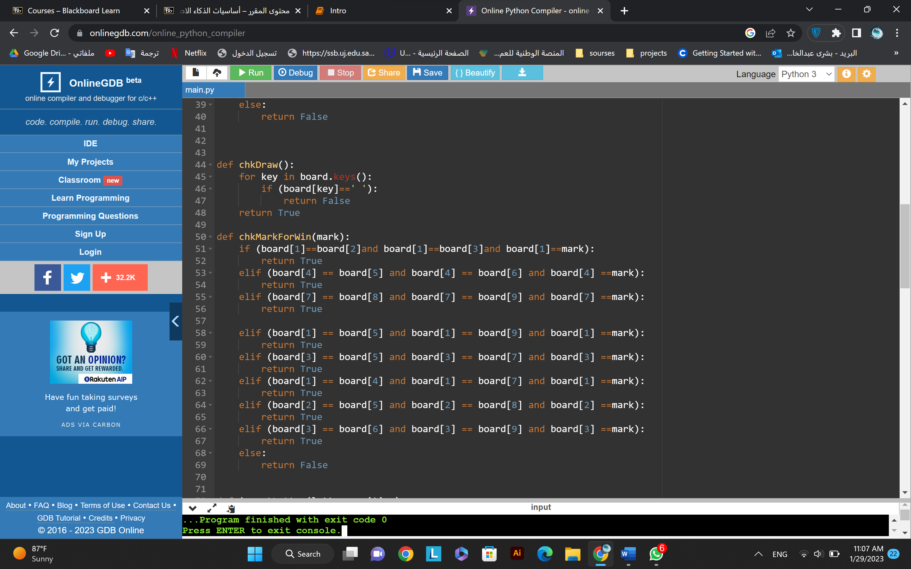

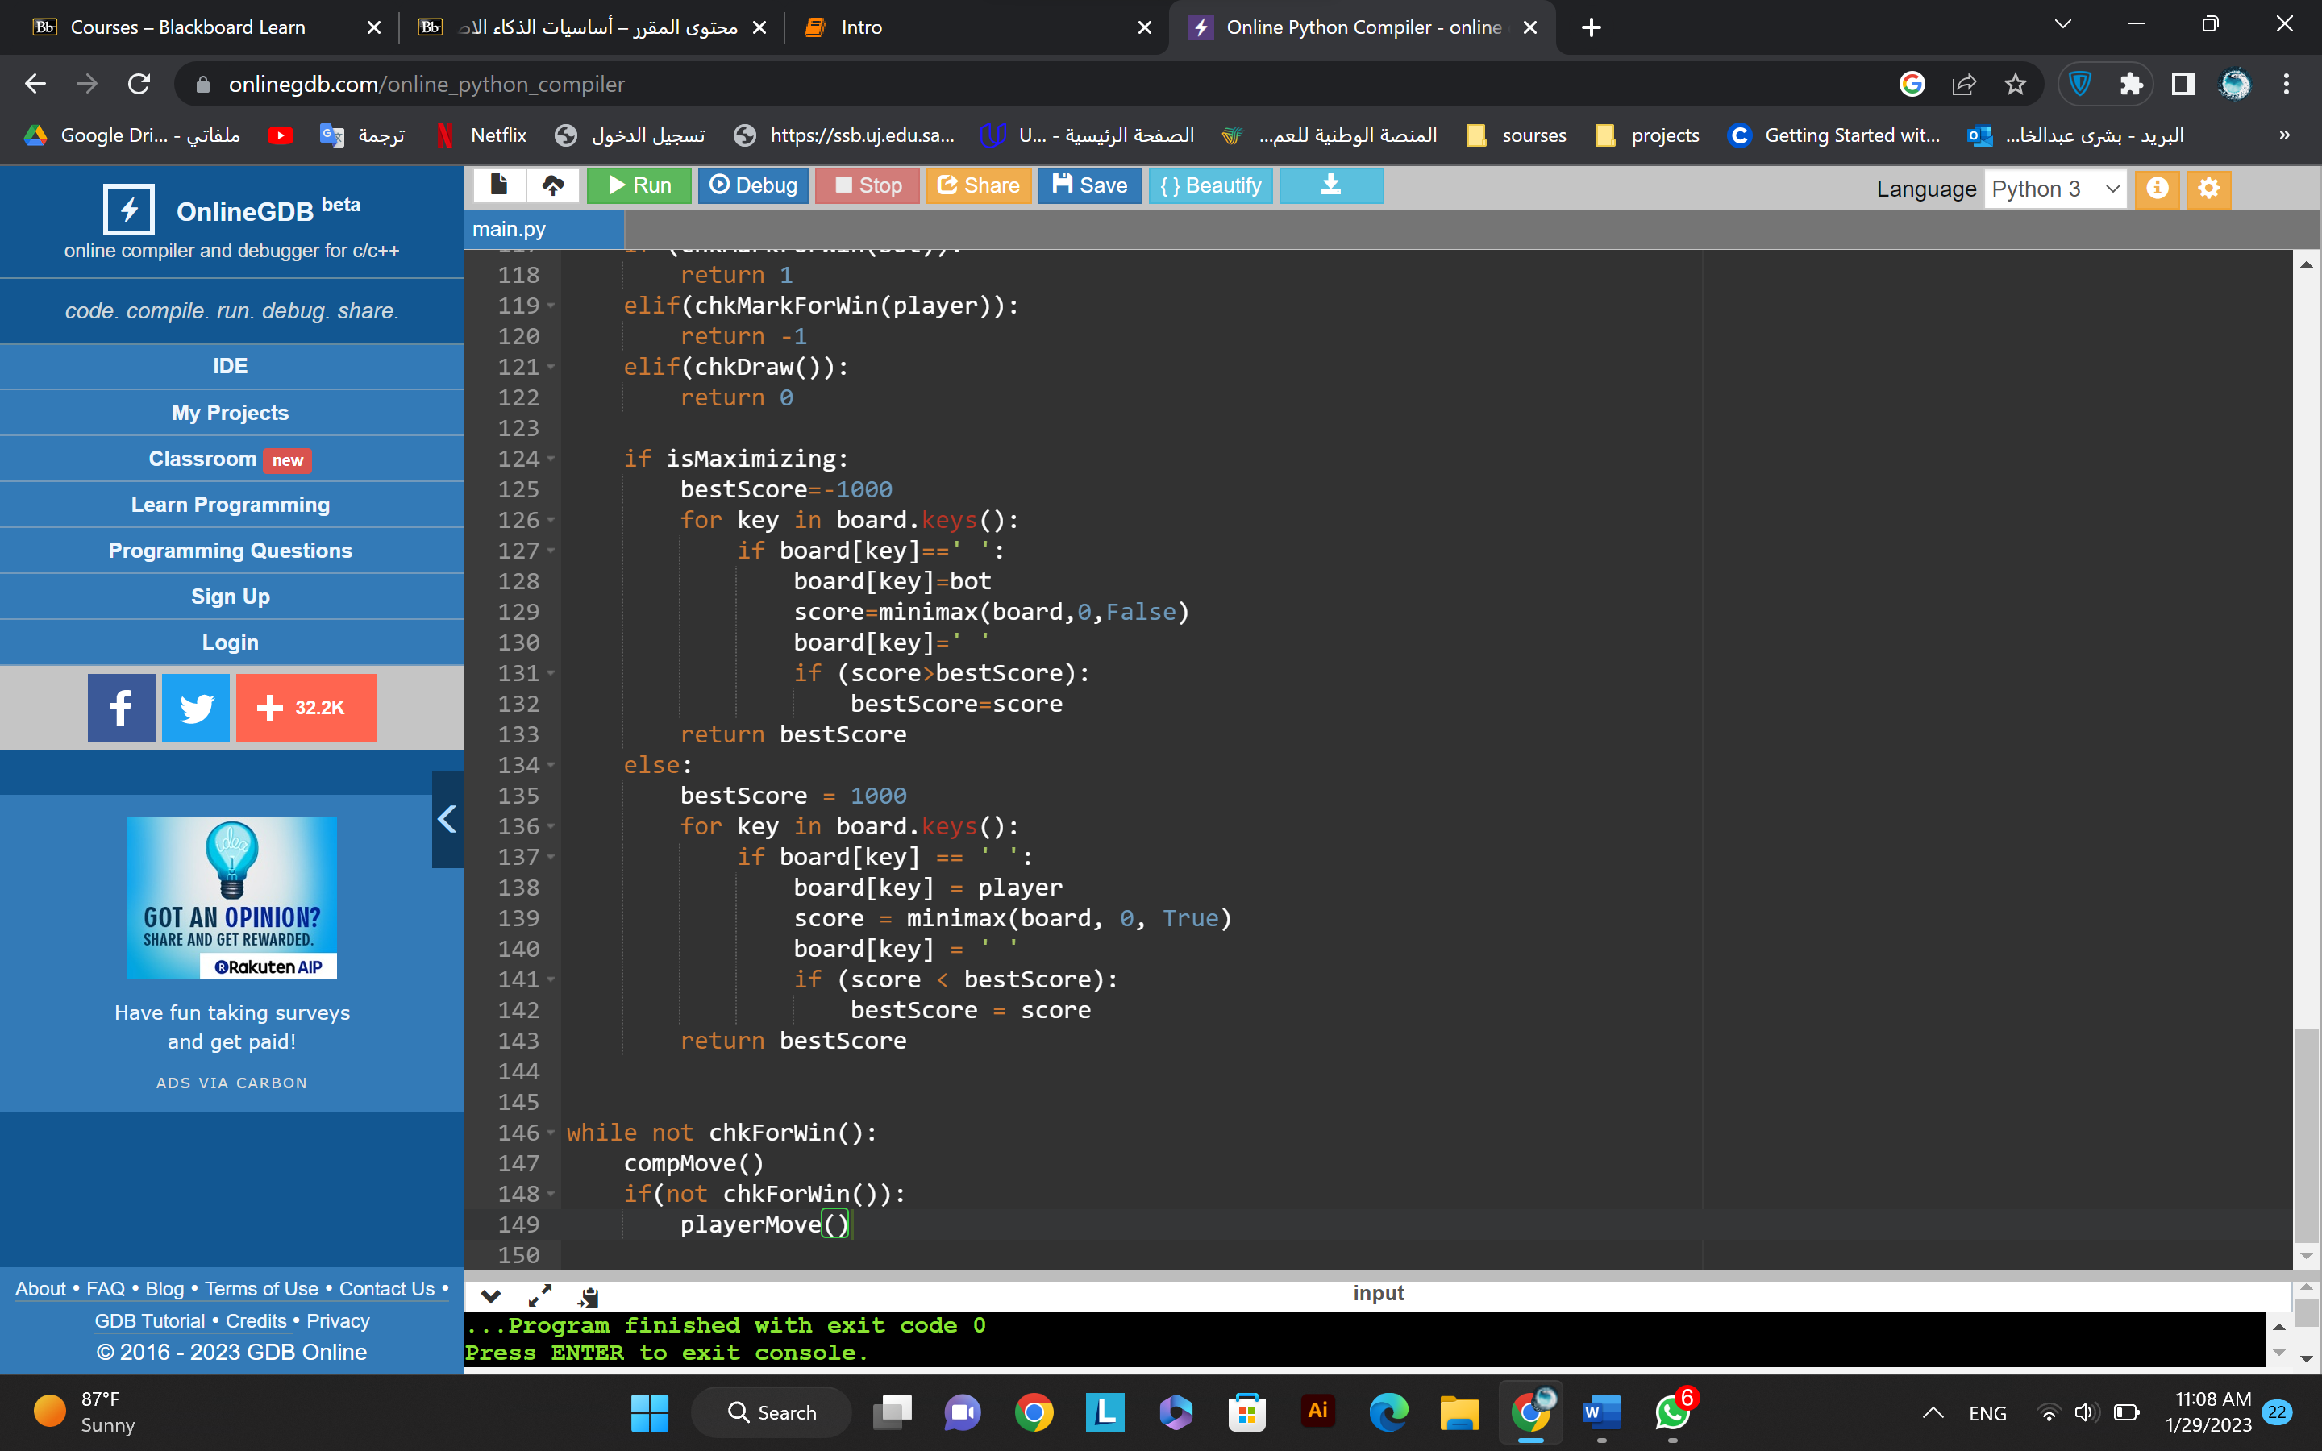

Output:

